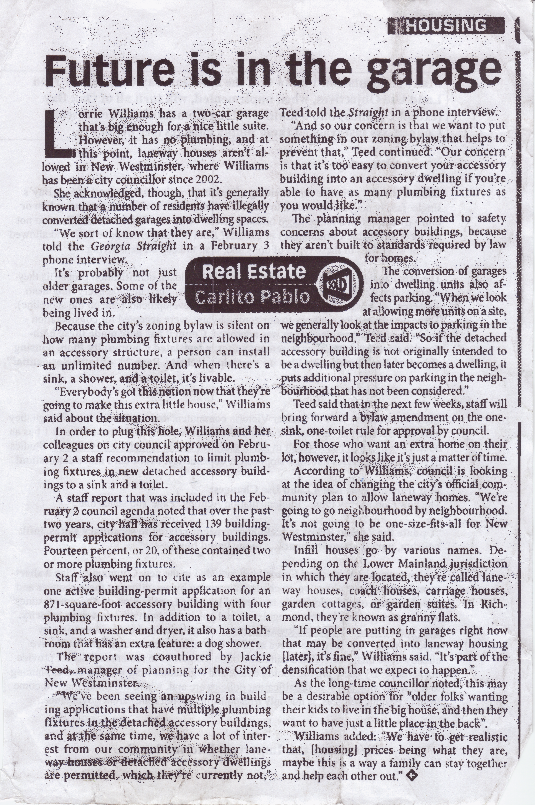

Oak Bay Watch’s Note:

Our Provincial Government and the Union of BC Municipalities recommend three types of “infill” densification:

- Invisible from the street, such as basement suites.
- Hidden from the street, such as lane-way suites and converted garages.
- Gentle – where new apartments are added above existing shops in shopping precincts already well served by transit.

It has been estimated that Oak Bay already has over a thousand (illegal and not-to-building code) suites dating back to the 1990s rental apartments shortage, however Council is not looking for solutions to deal with this unregulated situation. Instead our council is currently not only buying into and promoting Government “Invisible and Hidden” Infill recommendations in single family neighbourhoods but, is going further by stepping up easing zoning rules - rather than encouraging the real sensitive “Gentle” (the long term solution).

Our council is not alone in pushing “Invisible and Hidden” strategies while ignoring “Gentle Strategies” as most BC municipalities began this same process a decade ago. You may think that Oak Bay therefore need simply copy the most successful strategies/zoning rules that have already been implemented and proven in similar municipalities. The problem is that so far no strategy in any municipality has been lauded as a success by their existing residents - although the developers who lobbied hard for the strategies are well pleased. A good question for our council is – Which municipality are you using as a successful example/ model?

Ask yourself – Is garage and basement accommodation really what is needed by the existing residents of Oak Bay? In other countries this kind of band-aid accommodation is triggered in times of emergencies and dislocations. One reason so many families move to Canada is to escape from living in crowded, garage-like accommodation.

An analysis of the last sentence in the article reveals just how naïve the Council member who made this statement is: “We have to get realistic…..…maybe this is a way for a family to stay together and help each other out”. The reality is (not hers) that this type of accommodation is very unsuitable for families or multiple residents besides imposing on adjacent property owners.

Infill is a business and rents for infill units such as converted garages tend to be high so as to pay back the landlord for the cost of “to code” construction, and for the personal inconvenience. The “mortgage helper” reasoning often quoted by our local politicians to promote infill, is subject to Canada Mortgage and Housing Commission mortgage qualifying rules – that seem to reverse every few years. In other destination communities, many landlords have stopped renting their suites to locals because there is more money to be made from renting them, via the internet, for short term stays by Vacationers. This booming business opportunity has created a regulation and enforcement quagmire throughout Canada and the United States.

Which points out the critical issue of Oak Bay’s inadequate funding staffing and resources for municipal bylaw enforcement. Oak Bay lacks the ability to enforce the existing suites to comply with the current rules regarding safety, fire, code, and zoning. Can residents expect that the proposed wider, relaxed infill bylaws will be enforced, or will all suites, existing and new remain unregulated, unsafe and untaxed?

Oak Bay’s (Official Community Plan) OCPs design standards and housing objectives are clear: “Respect the privacy of adjoining properties” and “Address concerns parking, traffic, noise, affects on other properties.” To comply with the OCPs requirements means that garage-suites must be limited to very large lots (such as those in the Uplands), and there needs to be strict limits on the number of garage suites per given street. Such limits are required because there is no way of knowing how many occupants and cars will be present at the new garage suite - another difficult enforcement issue.

OakBayWatch has noticed that Designer and Architectural Magazines constantly print articles about big spacious homes, with large kitchens and walk in closets, but never articles about garage or basement suites. Some communities are now allowing shipping-containers that are converted to suites. Yes, you read that correctly and in addition some communities also permit multiple suites, (basement, attic, garage) on small single-family lots. Is this the next stage of Oak Bay Council’s planned infill development?

